

TECHNICALPROJECTREPORT

TITLE OF INVENTION /PROJECT:

INFINITY MIRROR

TEAM MEMBERS /INVENTORS:

|  |  |  |  |  |  |
| --- | --- | --- | --- | --- | --- |
| **S.**  **No.** | **Name** | **Department** | **Designation** | **Mobile** | **E-Mail** |
| 1. | Kiranjotsingh | ECE | Mentor | 9463909689 | kiranjotsingh.ece@cumal.in |
| 2. | Diyanshu | ECE | Student | 9453936443 | Rulesdivyaanshu@gmail.com |
| 3. | Rachna | ECE | Student | 8360587292 | aggrachna20@gmail.com |
| 4. | Mayank yadav | ECE | Student | 8393073356 | Cu.18bec1043@gmail.com |

# Section – 1 (IPR Related)

BRIEF ABSTRACT (500 WORDS):

An infinity mirror is a pair of parallel mirrors, which create a series of smaller and smaller reflections that appear to recede to infinity .They are used as room accents and in artwork.

A first mirror is held in spaced relationship to a second mirror by mounting means such as frame . First mirror is a partially reflecting type also called a two-way mirror. With first mirror adjacent to an observer, mirror will appear to be fully reflecting. If, however, a light source such as incandescent led light bulb is illuminated between first mirror and second mirror , the observer will see light mirror. Because second mirror is located behind first mirror , the observer will also see the image of led light bulb which is reflected from second mirror . Moreover, another image of led light bulb is reflected from first mirror to second mirror and then back to the observer. Each successive image diminishes in size and intensity and so appears farther away and less bright. Second mirror is preferably a fully reflecting mirror which may be a glass pane having a reflecting surface, such as the conventional silvered mirror.

, it will be observed that the successive images appear to form co-mirror of diminishing size and intensity, rather than discrete, separate images. Image by letting the light source, such as bulb, extend to touch first mirror, this

continuous column effect is achieved. If, instead, bulb were positioned intermediate first mirror and second mirror, discrete, separate images .

It will be apparent that either the first or second mirror or both need not be planar, so as to vary the display. Also, various patterns and shapes of holes can be used to achieve both visually pleasing and functional results,

merely by positioning a light source behind the second or fully reflecting mirror so that light will shine through the hole, it should be recognized that the portion of the light which passes through the first or partially reflecting mirror is not available in producing the reflected images. Consequently, having a more intense light source between the mirrors results in a more pronounced visual

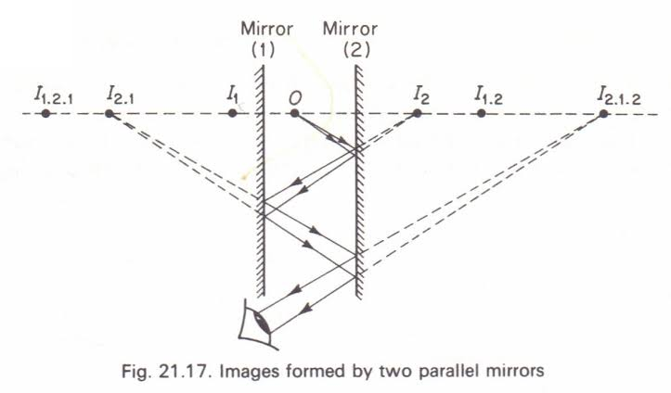

Problem Faced and how solved it

I made it with all the possibilities but I faced some problems during making frame then I take help from carpenter

Choosing mirror

EXISTING STATE-OF-THE-ART AND DRAWBACKS IN EXISTING STATE-OF-THE-ART

|  |  |  |
| --- | --- | --- |
| **S. No.** | **Existing state of art** | **Drawbacks in existing state of art** |
| 1 | U.S.PAT.NO.2,286,247 | Show device discloses a transparent mirror spaced from an opaque mirror with an object placed between the mirrors illuminated by a light bulb |
| 2 | Yayoi Kusama’s infintiy mirror series | Expensive |

BEEEDITIONAL MODIFICATIONS THAT YOU CAN PROPOSE TO IMPROVE UPON DRAWBACKS

• It is therefore an object of this invention to provide an infinity mirror display having one or more light sources at any desired location within the viewing area of the display

• it is also an object of this invention to provide an infinity mirror display in which the orientation of the light sources causes the successive images to appear as continuous light lines or columns

1

## BEEE LAB

 

ADVANTAGES

* They are used as a rom accents and in Art work

BLOCK DIAGRAM

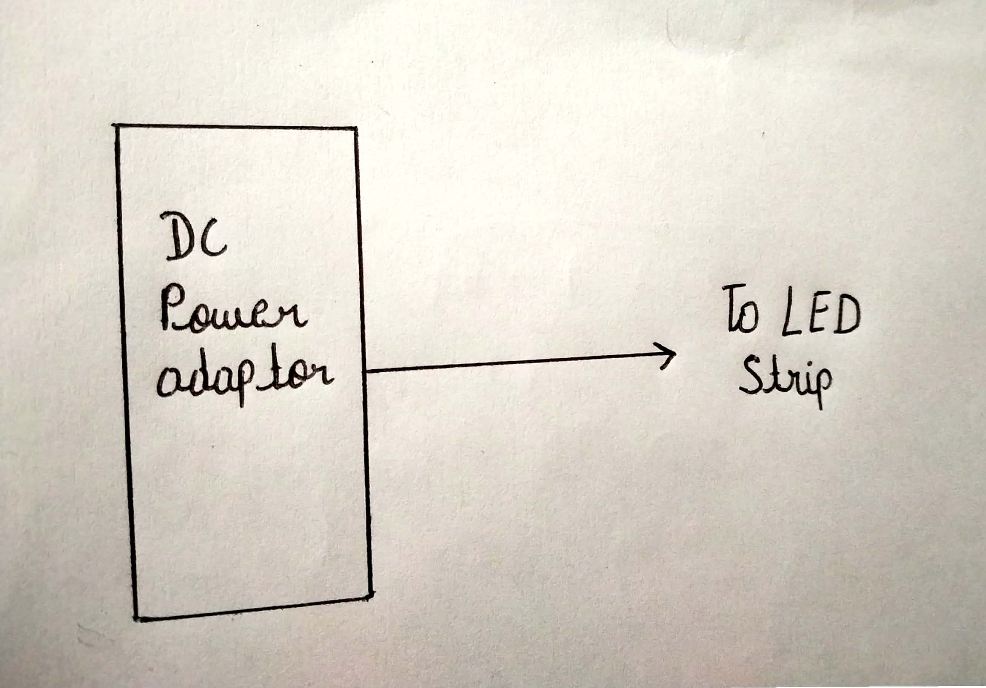

# Section – 2 (Real Project)

MATERIALS COST(RUPEE)

Wooden frame 150

12v white LED strip 100

Nails 30

Glue gun 179

Glue 40

DC power adaptor 100

Two way mirror 95

Total amount - 694

CIRCUIT DIDIAGRA

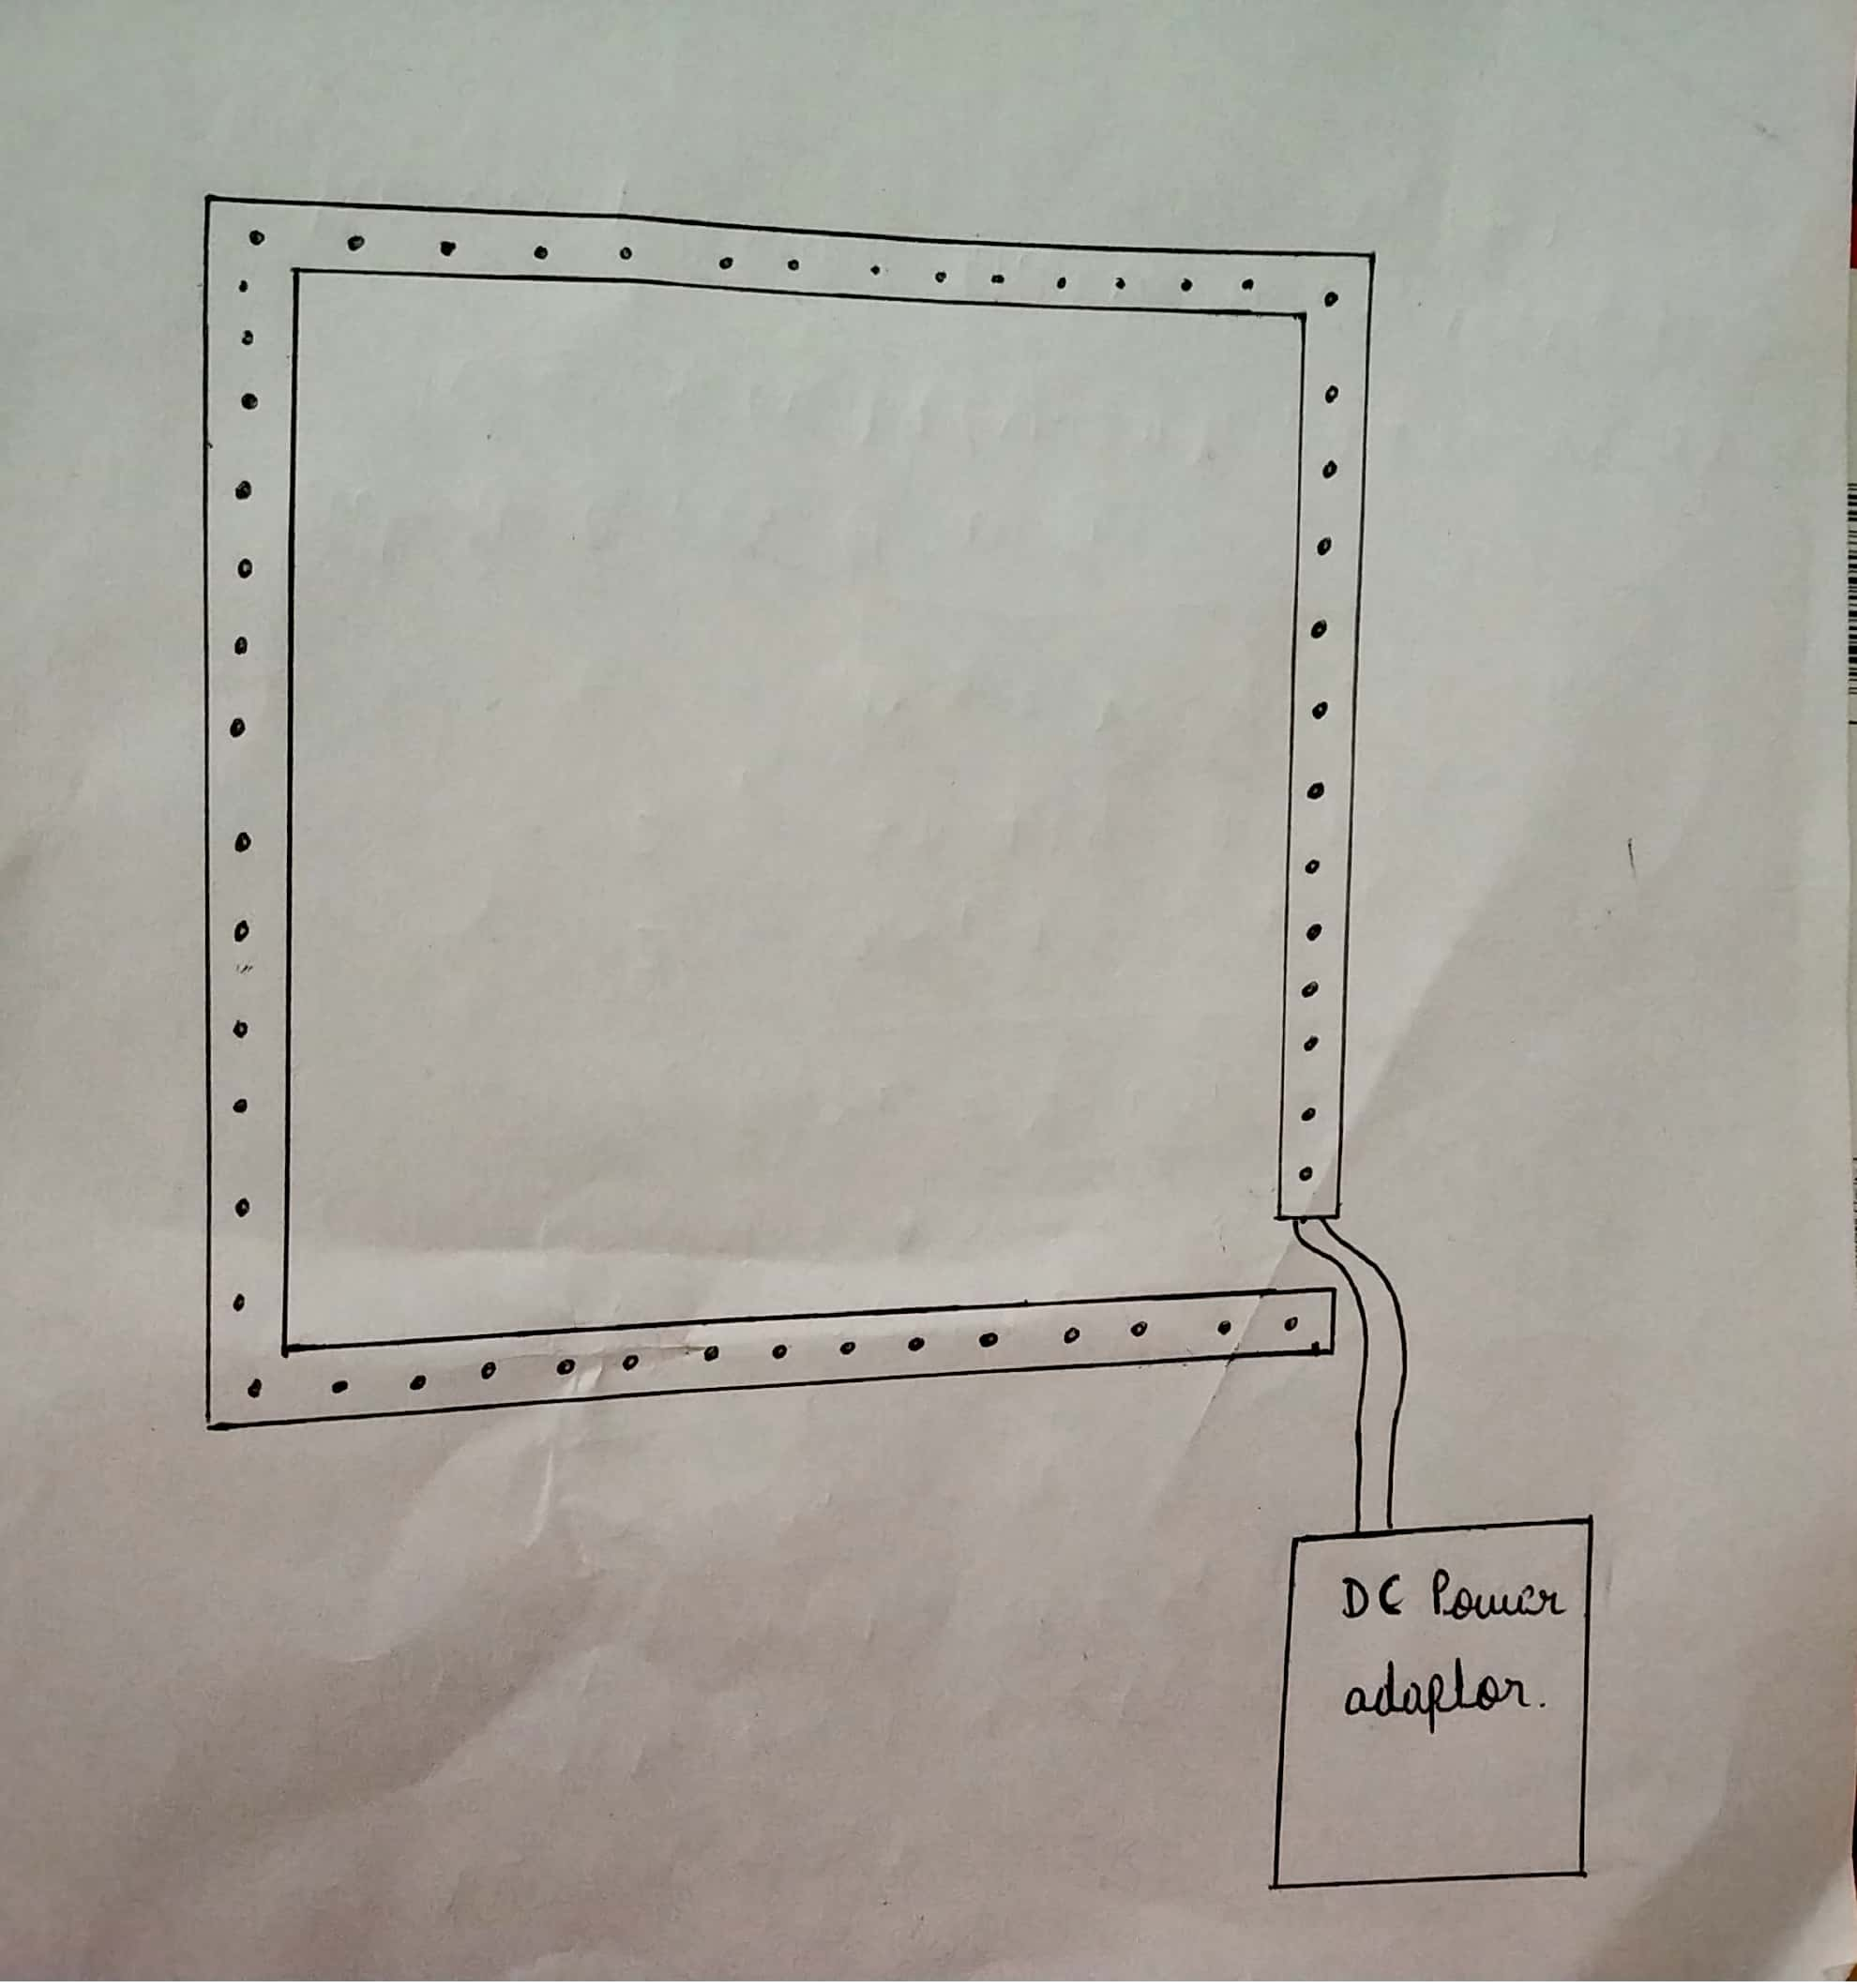

STEPS OF CIRCUIT COMPLETION

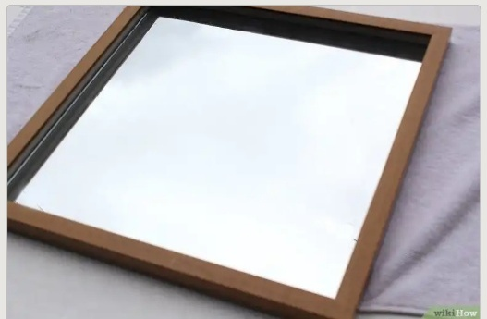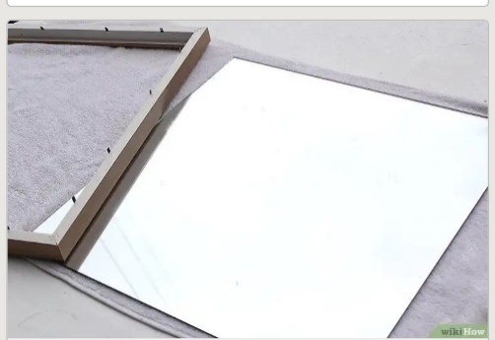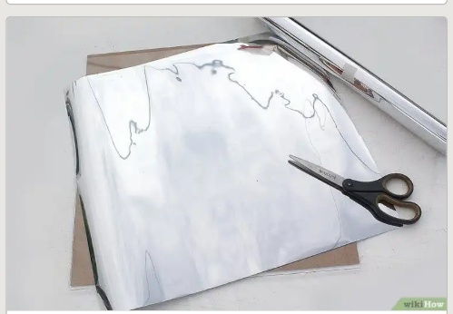1 2 3

4 5 6

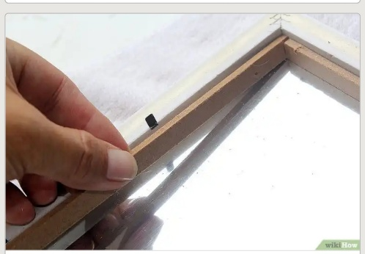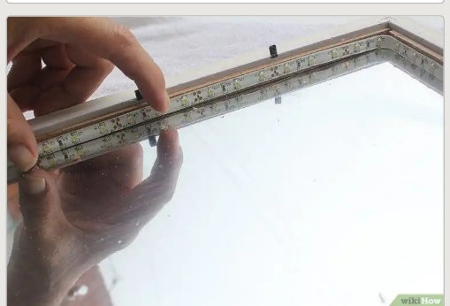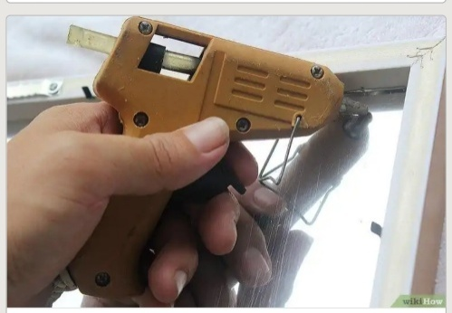

7 8 9

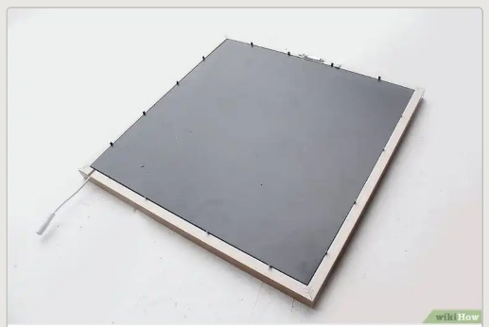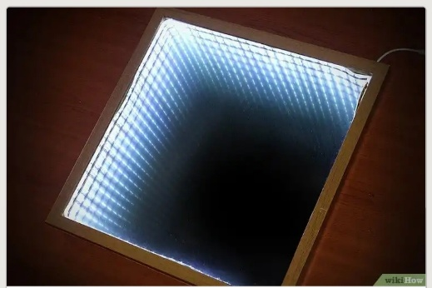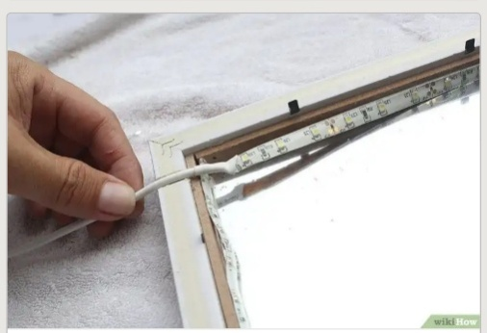

PROGRAM CODE

<http://github.com/mayankyadav46/infinity-Mirror.git>

2

## BEEE LAB